**Phonebook Program**

**Main Page**

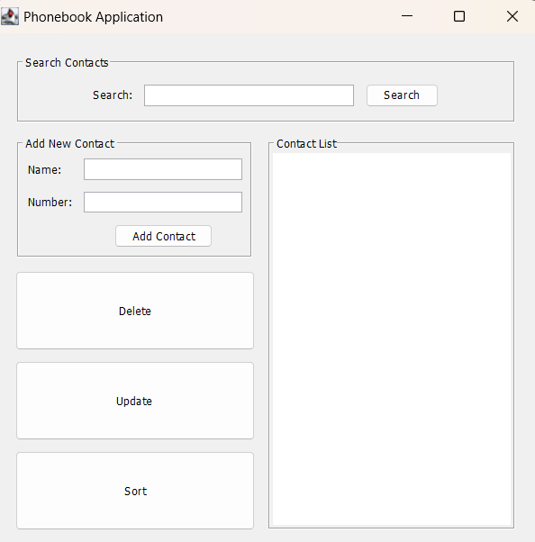

**Add**

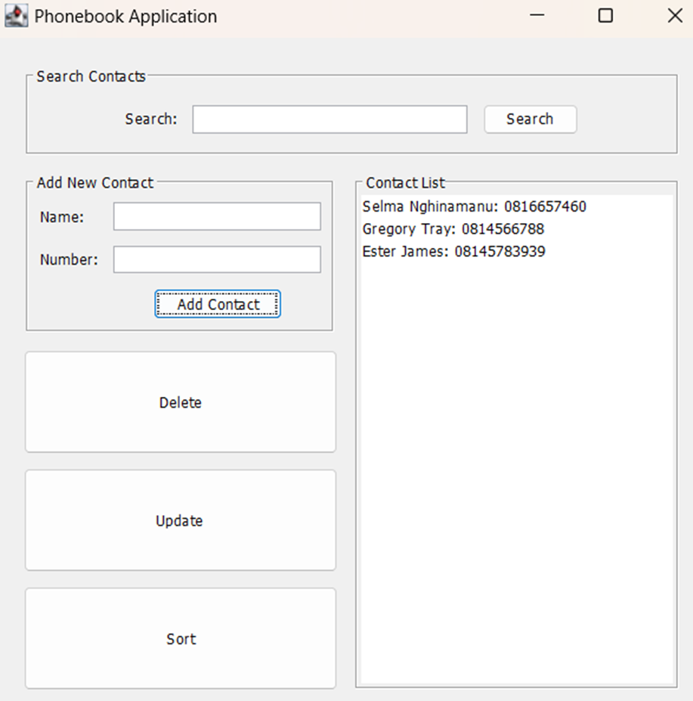

**Search**

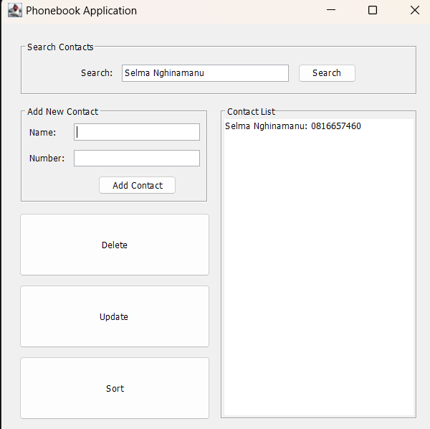

**Delete**

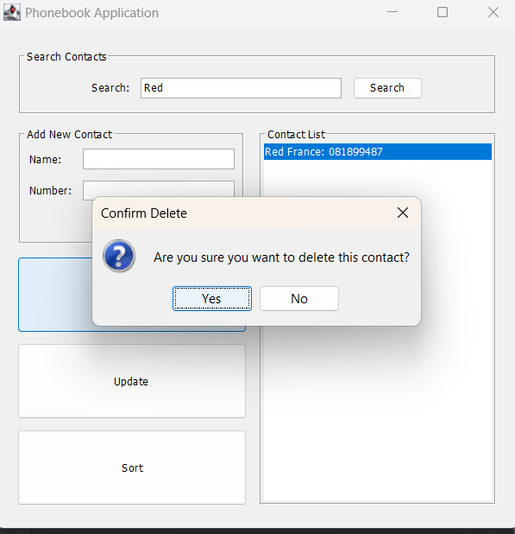

**It will show that the contact Red France is deleted from the contact list**

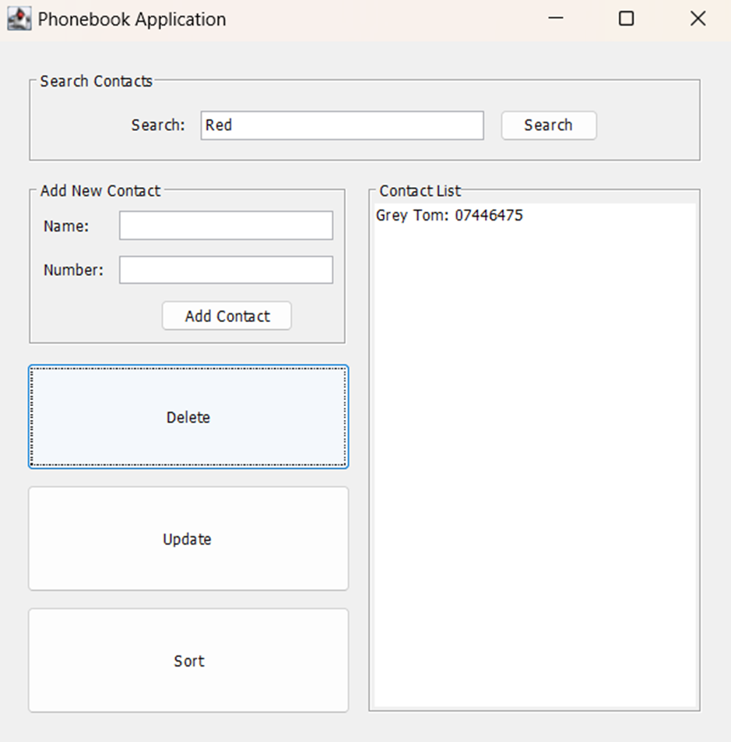

**Update**

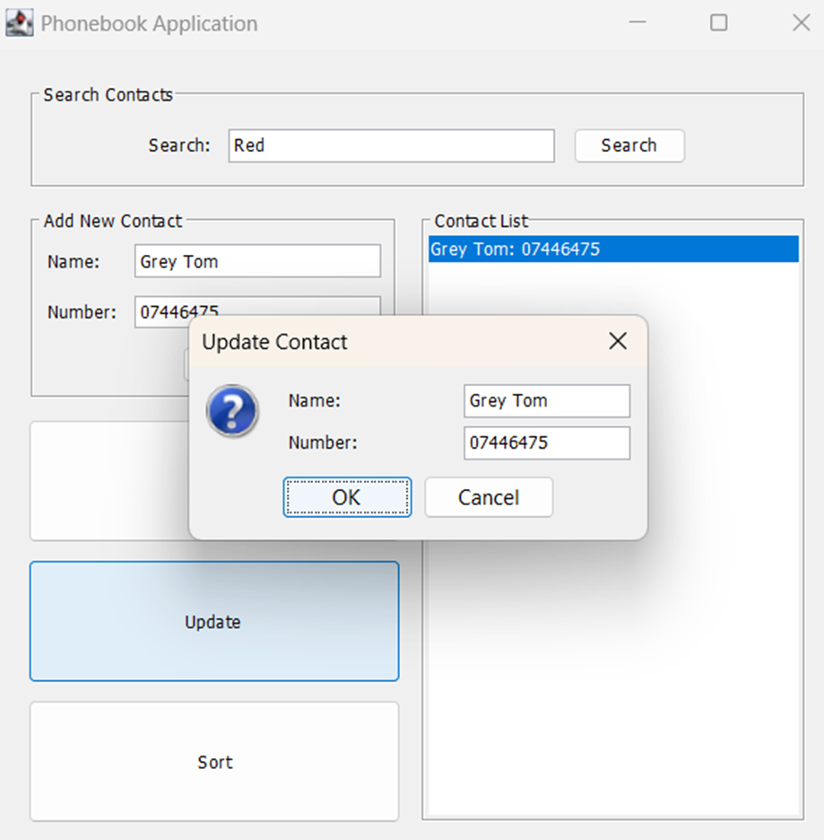

It will allow the user to update the contact Grey Tom

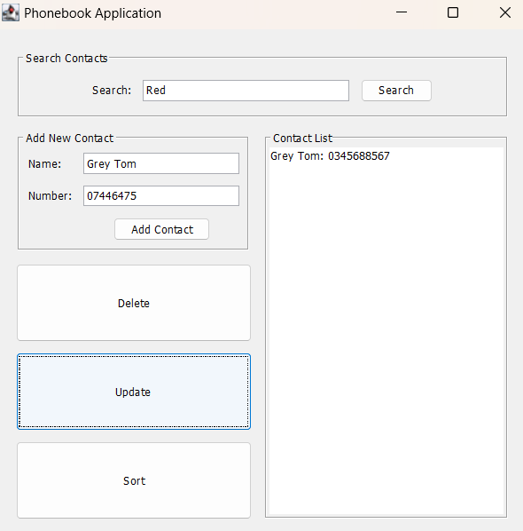

This shows that the contact Grey Tom was updated with a new number

**Sort**

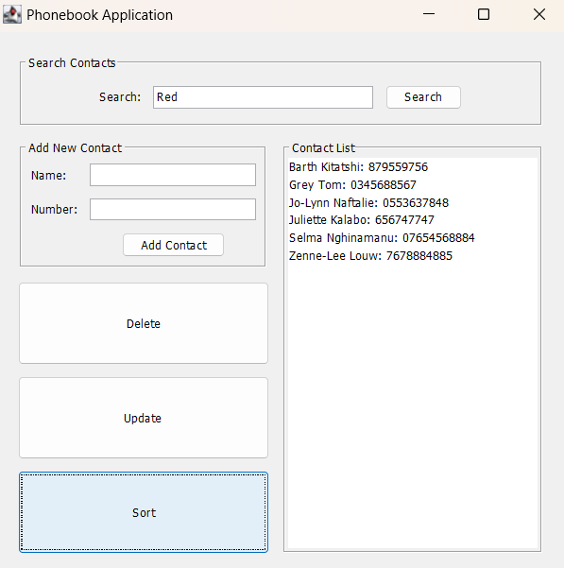

The contacts are sorted in alphabetical order from B to Z